**208W1A1299 DBMS LAB TASK 1**

**DATE : 31-03-2022**

**Q) Different types of DBMS Softwares.**

|  |  |  |  |  |  |  |  |  |  |  |
| --- | --- | --- | --- | --- | --- | --- | --- | --- | --- | --- |
| **Sno** | **Name** | **Features** | **Source** | **Developed**  **company** | **Version** | **Usage of**  **Software** | **Applications** | **Supported**  **OS** | **Developed**  **Year** | **Data model** |
| **1** | **PostgreSQL** | **Table inheritance** | **open source** | **PostgreSQL Global Development Group** | **14.0** | **primary data store for many web, mobile** | **Uber**  **Netflix**  **Instagram**  **Spotify** | **macOS Windows Linux FreeBSD** | **1996** | **relational model** |
| **2** | **MySQL** | **multi-version transaction support** | **open-source** | **Oracle Corporation** | **8.0.28** | **data warehousing, e-commerce, and logging** | **Airbnb**  **Netflix**  **Pinterest**  **Amazon** | **Linux**  **Solaris**  **macOS**  **Windows FreeBSD** | **1995** | **Relational model** |
| **3** | **Microsoft SQL Server** | **transaction processing, business intelligence** | **commercial** | **Microsoft** | **15.0** | **to manage multiple databases** | **Bank of America**  **DELL** | **Linux Microsoft Windows** | **1989** | **relational model** |
| **4** | **Oracle** | **Secured,**  **Less space,**  **Less cpu time** | **Commercial** | **Oracle** | **19c** | **Banking** | **LinkedIn**  **ebay** | **Windows**  **Linux**  **Mac os** | **1979** | **Multi model** |
| **5** | **Amazon RDS** | **Easy to install,**  **Inbuilt data**  **Restoration** | **Open source** | **Amazon** | **13.4** | **Shopping** | **Amazon.**  **CRED.** | **Windows**  **Linux**  **Mac os** | **2009** | **Relational** |
| **6** | **Tera Data** | **Data import,**  **Export easy,**  **Distributed**  **Data easy** | **Commercial** | **Tera data** | **16.20** | **Manage Large**  **data** | **Morgan Stanley**  **JPMorgan Chase** | **Windows**  **Linux**  **Mac os** | **1979** | **Multiple** |
| **7** | **IBM Db2** | **table partitioning high availability disaster recovery** | **Commercial** | **IBM** | **11.5.7** | **management of both structured and unstructured data** | **Fiserv** | **Linux**  **Unix**  **windows** | **1983** | **relational** |

**208W1A1299 DBMS LAB TASK 2**

**DATE : 07-04-2022**

**Q) Different types of MYSQL DataTypes**

* **MYSQL COMMANDS ARE CASE INSENSITIVE**

**MYSQL COMMANDS:**

* **show databases;**

**Usage : this command is used to view the databases present in the MYSQL software.**

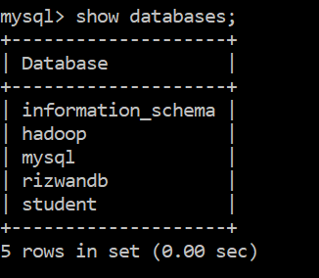

* **create database database_name;**

**Usage : this commad is used to create a database with the name we want .**

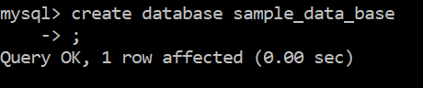

* **use database_name;**

**Usage : the database we want to use is selected with this commad**

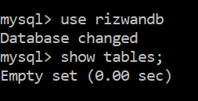

* **create table table_name( col1_name datatype(size), col2_name datatype(size),..));**

**Usage : this commad is used to create table with a particular name and give the coloum names with particular datatype and size**



* **show tables;**

**Usage : this command is used view all the tables in the particular database which we have selected previously**

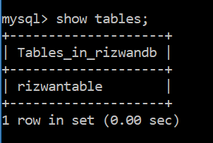

* **desc table_name;**

**Usage : this command is used to view the description of table like fields created and their datatyes**

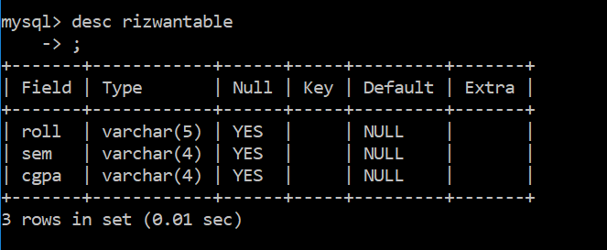

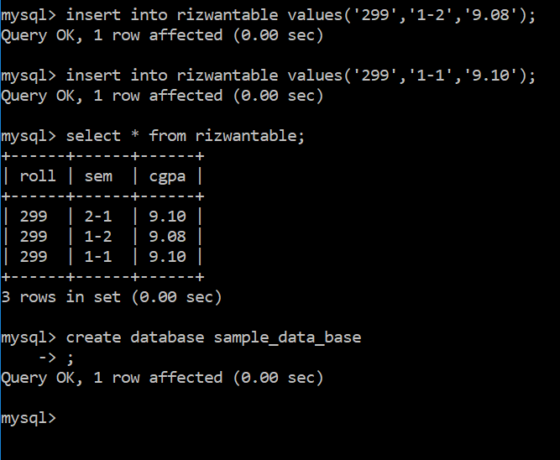**insert.PNG**